**Jenkins X**

* Jenkins X automates & accelarates CI and CD for developers on the cloud , so that they can focus on building applications.
* Jenkins X integrates with
  + Kubernetes
  + Tekton
  + KuberHealthy
* <https://jenkins-x.io/v3/about/maturity-matrix/>
* Architecture: <https://jenkins-x.io/v3/about/overview/>
* Lets Navigate to the Administration section <https://jenkins-x.io/v3/> 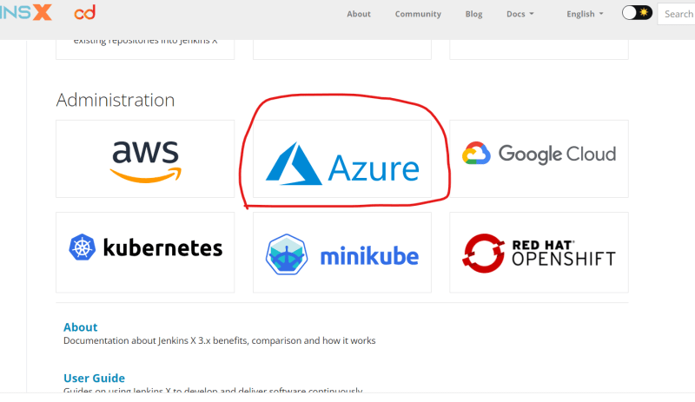
* Create a Git Repository in GitHub 